Enterprise Network Design and Implementation Using Huawei Datacom Technologies

Core Link Technologies
Full Documentation

Core Link Technologies – Full Documentation

1. Executive Summary
This document provides a complete technical design and configuration reference for Core Link Technologies network including a Headquarters (HQ) and Branch (BR1), interconnected through ISP routers using public IPs, static routing, RIP, and a GRE tunnel.
The design includes a full three‑tier switching architecture (Core, Aggregation, Access), VRRP high availability, LACP EtherChannel redundancy, wireless infrastructure with ACs and AP groups, DHCP services, AAA security, and IP addressing schemas for all VLANs.

2. Network Overview
The network includes two main sites: Headquarters (HQ) and Branch (BR1).
Connectivity between sites is achieved via ISP routers and a GRE tunnel carried over public IP addressing.
HQ uses dual core switches with full VRRP gateway redundancy and LACP-based inter-switch uplinks.
Each site features VLAN segmentation for HR, IT, CCTV, VOIP, Guest, Servers, Management, IoT, and Backup.
Wireless services are centrally managed through dual ACs (AC-HQ and AC-Suez) and CAPWAP AP deployment.

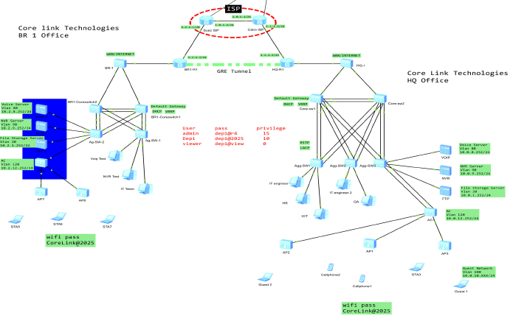

3. Physical & Interface Mapping
A mapping of all inter-device connections including router-to-router, core-to-aggregation, aggregation-to-access, and access-to-AP infrastructure.
All EtherChannel (Eth-Trunk) bundles are documented, including port assignments and uplink distribution.
🏢 HQ Site

HQ Core
Device | Interface | Connected To | Interface | Notes
HQ-R1 | G0/0/0 | HQ-1 | G0/0/1
HQ-R1 | G0/0/1 | ISP1 | G0/0/0
HQ-1 | G0/0/24 | Core-SW1 | G0/0/22
HQ-1 | G0/0/23 | Core-SW2 | G0/0/22
Core-SW1 | G0/0/22 | HQ-1 | G0/0/24
Core-SW1 | G0/0/23,24 | Core-SW2 | G0/0/23,24 | EtherChannel
Core-SW1 | G0/0/19,20 | Agg-SW1 | G0/0/23,24 | EtherChannel
Core-SW1 | G0/0/17,18 | Agg-SW2 | G0/0/23,24 | EtherChannel
Core-SW1 | G0/0/15,16 | Agg-SW3 | G0/0/23,24 | EtherChannel
Core-SW2 | G0/0/23,24 | Core-SW1 | G0/0/23,24 | EtherChannel
Core-SW2 | G0/0/19,20 | Agg-SW3 | G0/0/21,22 | EtherChannel
Core-SW2 | G0/0/17,18 | Agg-SW2 | G0/0/21,22 | EtherChannel
Core-SW2 | G0/0/15,16 | Agg-SW1 | G0/0/21,22 | EtherChannel

HQ Aggregation & Access
Device | Interface | Connected To | Interface | Notes
Agg-SW1 | G0/0/23,24 | Core-SW1 | G0/0/19,20 | EtherChannel
Agg-SW1 | G0/0/21,22 | Core-SW2 | G0/0/15,16 | EtherChannel
Agg-SW2 | G0/0/23,24 | Core-SW1 | G0/0/17,18 | EtherChannel
Agg-SW2 | G0/0/21,22 | Core-SW2 | G0/0/17,18 | EtherChannel
Agg-SW3 | G0/0/23,24 | Core-SW1 | G0/0/15,16 | EtherChannel
Agg-SW3 | G0/0/21,22 | Core-SW2 | G0/0/19,20 | EtherChannel
Agg-SW3 | G0/0/19,20 | AC1 | G0/0/7,8 | EtherChannel
Agg-SW3 | G0/0/3 | VoIP Server | Ethernet0/0/0
Agg-SW3 | G0/0/2 | NVR Server | Ethernet0/0/0
Agg-SW3 | G0/0/1 | File Storage | Ethernet0/0/0
AC1 | G0/0/7,8 | Agg-SW3 | G0/0/19,20 | EtherChannel
AC1 | G0/0/2 | AP3 | G0/0/4
AC1 | G0/0/4 | AP1 | G0/0/4
AC1 | G0/0/6 | AP2 | G0/0/4

🏬 Branch Site (BR1)
Device | Interface | Connected To | Interface | Notes
BR1-R1 | G0/0/1 | ISP2 | G0/0/1
BR1-R1 | G0/0/0 | BR-1 | G0/0/1
BR-1 | G0/0/23 | BR1-CoreSwitch1 | G0/0/16
BR-1 | G0/0/24 | BR1-CoreSwitch2 | G0/0/16
CoreSwitch1 | G0/0/21,22 | CoreSwitch2 | G0/0/21,22 | EtherChannel
CoreSwitch1 | G0/0/17,18 | AG-SW-1 | G0/0/23,24 | EtherChannel
CoreSwitch1 | G0/0/19,20 | AG-SW-2 | G0/0/21,22 | EtherChannel
CoreSwitch2 | G0/0/21,22 | CoreSwitch1 | G0/0/21,22 | EtherChannel
CoreSwitch2 | G0/0/17,18 | AG-SW-1 | G0/0/21,22 | EtherChannel
CoreSwitch2 | G0/0/19,20 | AG-SW-2 | G0/0/21,22 | EtherChannel
AG-SW-1 | G0/0/23,24 | CoreSwitch1 | G0/0/17,18 | EtherChannel
AG-SW-1 | G0/0/21,22 | CoreSwitch2 | G0/0/17,18 | EtherChannel
AG-SW-2 | G0/0/23,24 | CoreSwitch2 | G0/0/19,20 | EtherChannel
AG-SW-2 | G0/0/21,22 | CoreSwitch1 | G0/0/20,19 | EtherChannel
AG-SW-2 | G0/0/16 | AC2 | G0/0/8
AG-SW-2 | G0/0/17 | File Storage 2 | Ethernet0/0/0
AG-SW-2 | G0/0/18 | NVR Server 2 | Ethernet0/0/0
AG-SW-2 | G0/0/19 | VoIP Server 2 | Ethernet0/0/0
AC2 | G0/0/4 | AP7 | G0/0/0
AC2 | G0/0/6 | AP6 | G0/0/0

ISP Chain
Device | Interface | Connected To | Interface
ISP1 | G0/0/1 | HQ-R1 | G0/0/1
ISP1 | G0/0/0 | ISP2 | G0/0/0
ISP2 | G0/0/0 | ISP1 | G0/0/0
ISP2 | G0/0/1 | BR1-R1 | G0/0/1

4. VLAN and IP Addressing Plan
VLANs include Management, IT, HR, CCTV, Guest, VOIP, Core Applications, Servers, DMZ, IoT, Backup, and WLAN SSIDs.
Each VLAN is assigned a subnet and VRRP virtual gateway on the core switches for redundancy.
DHCP pools are configured on Core-SW1 and Core-SW2 (HQ) and similarly on BR1 cores.
Here’s your HQ VLAN configuration arranged in a clean, structured table:

🏢 HQ VLAN Configuration Table
VLAN ID | Subnet | Default Gateway | Purpose
10 | 10.0.0.0/24 | 10.0.0.1 | Network device management (switches, routers)
20 | 10.0.1.0/24 | 10.0.1.1 | Network infra (NTP, DNS internal, AD DS replicas)
30 | 10.0.2.0/23 | 10.0.2.1 | Application servers, DB, internal services (HQ primary)
40 | 10.0.4.0/24 | 10.0.4.1 | Public-facing services (webmail, reverse-proxy, APIs)
50 | 10.0.5.0/24 | 10.0.5.1 | Core business applications (ERP, finance)
60 | 10.0.6.0/24 | 10.0.6.1 | HR systems / restricted systems
70 | 10.0.7.0/24 | 10.0.7.1 | IT engineers / admin workstations
80 | 10.0.8.0/24 | 10.0.8.1 | IP Phones (native voice VLAN)
90 | 10.0.9.0/24 | 10.0.9.1 | IP cameras / video storage
100 | 10.0.10.0/24 | 10.0.10.1 | Guest WIFI / internet-only clients
110 | 10.0.11.0/24 | 10.0.11.1 | Dev/QA lab / sensitive environments
120 | 10.0.12.0/24 | 10.0.12.1 | AP management and controller traffic
200 | 10.0.20.0/24 | 10.0.20.1 | Printers, IoT sensors, building automation
250 | 10.0.21.0/24 | 10.0.21.1 | Backup network / replication

Here’s the VLAN configuration for 🏬 Branch 1 arranged in a structured table:

🏬 Branch 1 VLAN Configuration Table
VLAN ID | Subnet | Default Gateway | Purpose
10 | 10.2.0.0/24 | 10.2.0.1 | Network device management (switches, routers)
20 | 10.2.1.0/24 | 10.2.1.1 | Network infra (NTP, DNS internal, AD DS replicas)
30 | 10.2.2.0/23 | 10.2.2.1 | Application servers, DB, internal services (branch servers)
40 | 10.2.4.0/24 | 10.2.4.1 | Public-facing services (branch proxy, local apps)
50 | 10.2.5.0/24 | 10.2.5.1 | Core business applications (ERP access, finance)
60 | 10.2.6.0/24 | 10.2.6.1 | HR systems / restricted systems
70 | 10.2.7.0/24 | 10.2.7.1 | IT engineers / admin workstations
80 | 10.2.8.0/24 | 10.2.8.1 | IP Phones (native voice VLAN)
90 | 10.2.9.0/24 | 10.2.9.1 | IP cameras / video storage
100 | 10.2.10.0/24 | 10.2.10.1 | Guest WIFI / internet-only clients
110 | 10.2.11.0/24 | 10.2.11.1 | Dev/QA lab / sensitive environments
120 | 10.2.12.0/24 | 10.2.12.1 | AP management and controller traffic
200 | 10.2.20.0/24 | 10.2.20.1 | Printers, IoT sensors, building automation
250 | 10.2.21.0/24 | 10.2.21.1 | Backup network / replication

5. Routing Design
HQ and Branch are connected via a GRE tunnel established between BR1-R1 and HQ router.
Static routing ensures default route propagation to ISP next-hop.
RIP version 2 is used internally between routers to advertise internal networks through the GRE tunnel.
Routing table convergence allows full reachability between HQ subnets and BR1 subnets.

6. Redundancy & High Availability
Dual Core switches at HQ and BR1 use VRRP for gateway redundancy.
LACP EtherChannels provide link-level redundancy between core, aggregation, and access layers.
RSTP ensures loop-free topology with fast convergence.
Wireless APs are dual-registered across AC-HQ and AC-Suez for failover.

7. Wireless Network Design
Wireless network uses Huawei ACs for centralized management.
SSID 'Corelink Technologies' is broadcast using WPA2-PSK security.
APs are grouped under CORELINK-APs group with both radios broadcasting same SSID.
CAPWAP tunnels connect APs to AC-HQ or AC-Suez depending on site.

8. Security Architecture
AAA used for admin authentication on network devices.
SSH secure algorithms set (AES, SHA256).
Illegal MAC address alarms enabled across all switches.
STP edge-port disabled on trunks to prevent rogue STP influence.
DHCP exclusion ranges used to protect infrastructure addresses.

9. Testing & Validation Procedures
Connectivity Tests:
• Ping between HQ and Branch via GRE tunnel.

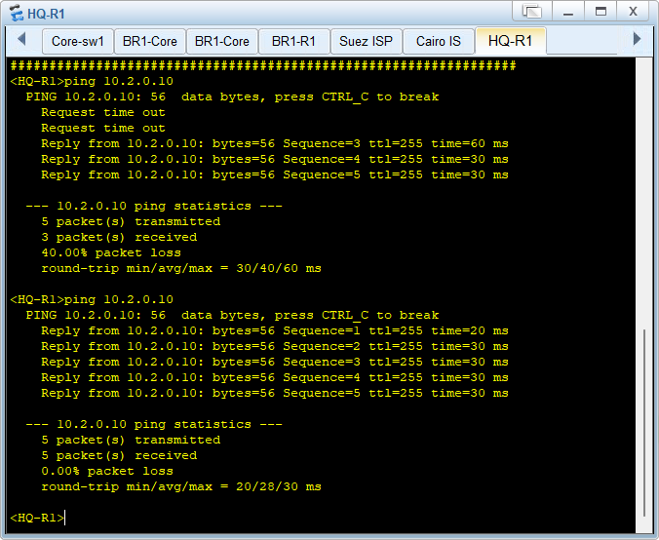

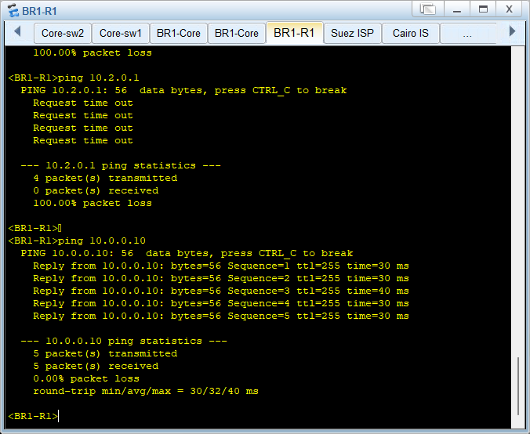

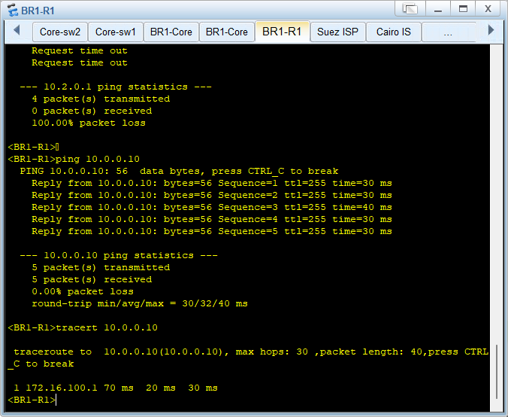

• Ping between VLANs inside HQ and BR1.
Pc 1 from HQ to FTP server in BR1

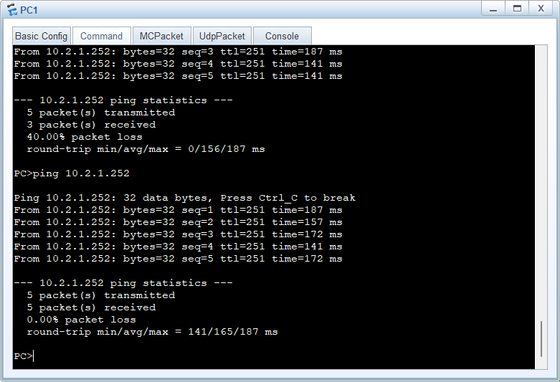
• DHCP address assignment validation in all VLANs.
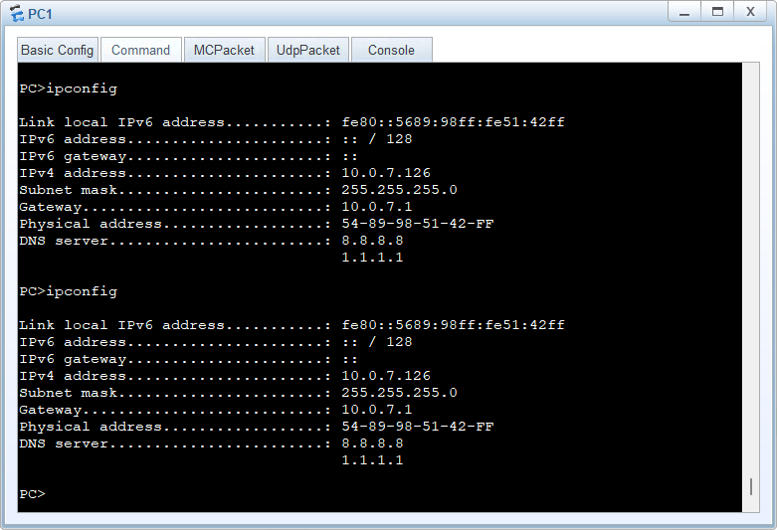

Failover Tests:
• VRRP Master/Backup role switching.
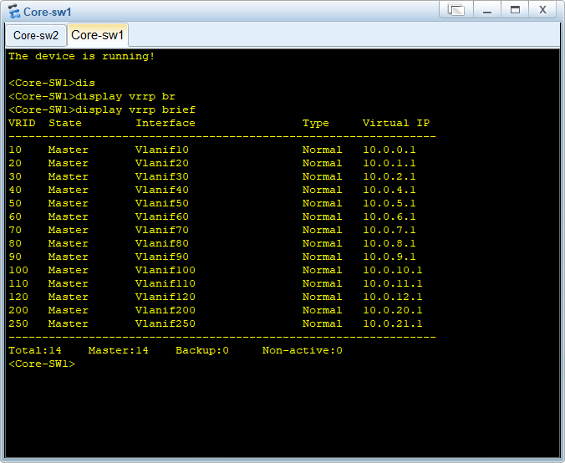

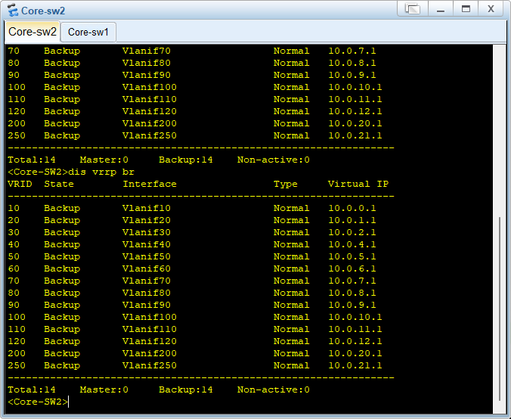

Wireless Tests:
• AP registration on AC.

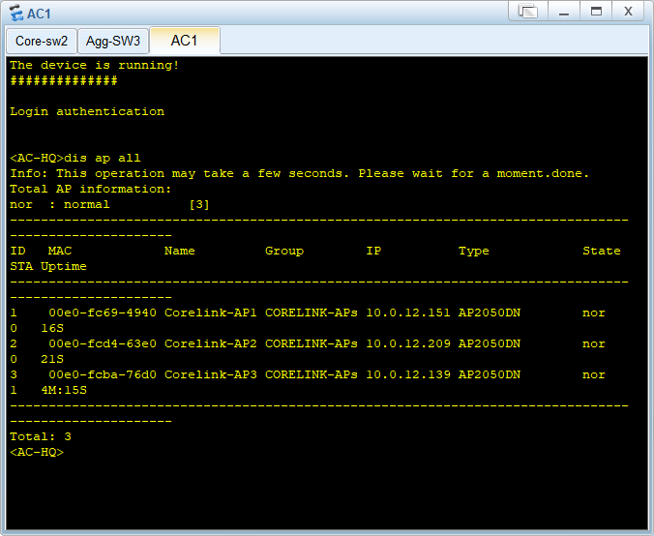

• SSID visibility and client connectivity.
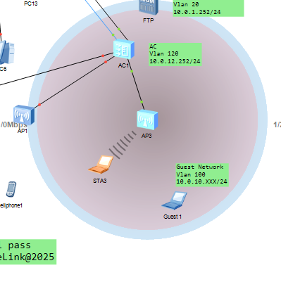

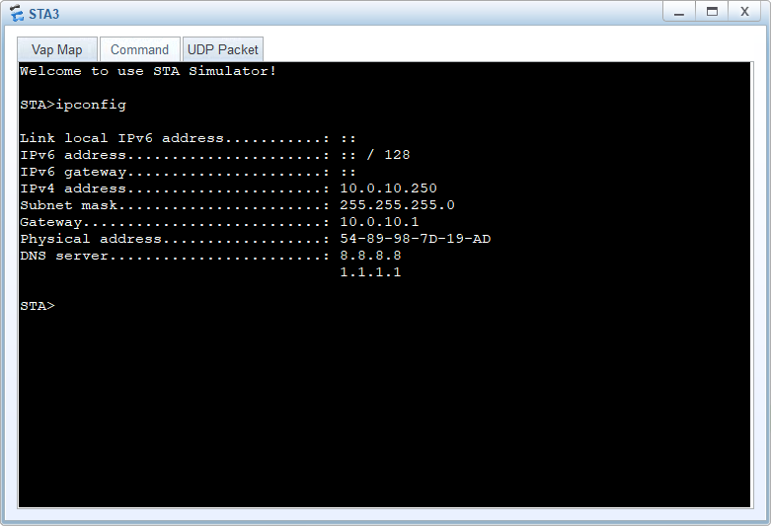

10. Troubleshooting Guide
Common Issues and Fixes:
• GRE Tunnel Down: Check source/destination public IPs and route to remote endpoint.
• VRRP Not Master: Verify priority settings and interface status.
• LACP Mismatch: Ensure trunk ports have identical configuration on both ends.
• DHCP Not Assigning: Confirm interface VLANIF DHCP select global/relay.
• AP Not Joining: Check CAPWAP source IP and routing to AC.

11. Maintenance Procedures
• Regular backup of switch and router configurations.
• Monitor LLDP/NDP/NTDP for topology changes.
• Verify VRRP state regularly for high availability.
• Apply firmware updates during maintenance windows.

12. Detailed Configuration Documentation
- HQ main router
sysname HQ-R1
ftp server enable
snmp-agent local-engineid 800007DB03000000000000
snmp-agent
clock timezone China-Standard-Time minus 08:00:00
portal local-server load flash:/portalpage.zip
drop illegal-mac alarmundo info-center enable
lldp enable
wlan ac-global carrier id other ac id 0
set cpu-usage threshold 80 restore 75
acl number 3000
rule 5 permit ip source 10.0.10.0 0.0.0.255
aaa
authentication-scheme default
authorization-scheme default
accounting-scheme default
domain default
domain default_admin
local-user depi password cipher %$%${j,`W<&8x=V}=<4Lz4(/8X_S%$%$
local-user depi privilege level 10
local-user depi service-type telnet ssh ftp
local-user admin password cipher %$%$PO%0CTa%]-BUo8)@.rq%8X_1%$%$
local-user admin privilege level 15
local-user admin service-type telnet ssh ftp
local-user viewer password cipher %$%$qgRW:E5B<blJQ!fMNJ58X_L%$%$
local-user viewer privilege level 0
local-user viewer service-type telnet ssh ftp
firewall zone Local
priority 15
interface GigabitEthernet0/0/0
ip address 10.0.0.10 255.255.255.0
interface GigabitEthernet0/0/1
ip address 1.1.1.2 255.255.255.0
nat outbound 3000
interface GigabitEthernet0/0/2
interface NULL0
interface Tunnel0/0/0
ip address 172.16.100.1 255.255.255.252
tunnel-protocol gre
source GigabitEthernet0/0/1
destination 1.2.1.2
stelnet server enable
ip route-static 0.0.0.0 0.0.0.0 1.1.1.1
ip route-static 1.2.1.2 255.255.255.255 1.1.1.1
ip route-static 10.2.0.0 255.255.0.0 172.16.100.2
user-interface con 0
authentication-mode password
user-interface vty 0 4
authentication-mode aaa
idle-timeout 10 0
user-interface vty 16 20
wlan ac
return
<HQ-R1>

- HQ Core-sw-1
sysname Core-SW1
FTP server enable
undo info-center enable
vlan batch 10 20 30 40 50 60 70 80 90 100
vlan batch 110 120 200 250
stp mode rstp
stp instance 0 priority 0
cluster enable
ntdp enable
ndp enable
lldp enable
undo nap slave enable
drop illegal-mac alarm
dhcp enable
diffserv domain default
acl number 3999
rule 5 permit ip source 0.0.0.0 0 destination 255.255.255.255 0
rule 10 permit ip source 10.0.0.0 0.0.0.255 destination 10.0.0.0 0.0.0.255
rule 15 permit ip source 10.0.1.0 0.0.0.255 destination 10.0.1.0 0.0.0.255
rule 20 permit ip source 10.0.2.0 0.0.1.255 destination 10.0.2.0 0.0.1.255
rule 25 permit ip source 10.0.4.0 0.0.0.255 destination 10.0.4.0 0.0.0.255
rule 30 permit ip source 10.0.5.0 0.0.0.255 destination 10.0.5.0 0.0.0.255
rule 35 permit ip source 10.0.6.0 0.0.0.255 destination 10.0.6.0 0.0.0.255
rule 40 permit ip source 10.0.7.0 0.0.0.255 destination 10.0.7.0 0.0.0.255
rule 45 permit ip source 10.0.8.0 0.0.0.255 destination 10.0.8.0 0.0.0.255
rule 50 permit ip source 10.0.9.0 0.0.0.255 destination 10.0.9.0 0.0.0.255
rule 55 permit ip source 10.0.10.0 0.0.0.255 destination 10.0.10.0 0.0.0.255
rule 60 permit ip source 10.0.11.0 0.0.0.255 destination 10.0.11.0 0.0.0.255
rule 65 permit ip source 10.0.12.0 0.0.0.255 destination 10.0.12.0 0.0.0.255
rule 70 permit ip source 10.0.20.0 0.0.0.255 destination 10.0.20.0 0.0.0.255
rule 75 permit ip source 10.0.21.0 0.0.0.255 destination 10.0.21.0 0.0.0.255
rule 80 permit ip source 10.0.0.0 0.0.0.255 destination 10.0.1.0 0.0.0.255
rule 85 permit ip source 10.0.0.0 0.0.0.255 destination 10.0.2.0 0.0.1.255
rule 90 permit ip source 10.0.0.0 0.0.0.255 destination 10.0.21.0 0.0.0.255
rule 95 permit ip source 10.0.2.0 0.0.1.255 destination 10.0.1.0 0.0.0.255
rule 100 permit ip source 10.0.2.0 0.0.1.255 destination 10.0.5.0 0.0.0.255
rule 105 permit ip source 10.0.2.0 0.0.1.255 destination 10.0.21.0 0.0.0.255
rule 110 permit ip source 10.0.4.0 0.0.0.255 destination 10.0.1.0 0.0.0.255
rule 115 permit ip source 10.0.4.0 0.0.0.255 destination 10.0.2.0 0.0.1.255
rule 120 permit ip source 10.0.5.0 0.0.0.255 destination 10.0.1.0 0.0.0.255
rule 125 permit ip source 10.0.5.0 0.0.0.255 destination 10.0.2.0 0.0.1.255
rule 130 permit ip source 10.0.5.0 0.0.0.255 destination 10.0.6.0 0.0.0.255
rule 135 permit ip source 10.0.6.0 0.0.0.255 destination 10.0.1.0 0.0.0.255
rule 140 permit ip source 10.0.6.0 0.0.0.255 destination 10.0.5.0 0.0.0.255
rule 145 permit ip source 10.0.7.0 0.0.0.255 destination 10.0.0.0 0.0.15.255
rule 150 deny ip source 10.0.7.0 0.0.0.255 destination 10.0.10.0 0.0.0.255
rule 155 deny ip source 10.0.7.0 0.0.0.255 destination 10.0.20.0 0.0.0.255
rule 160 deny ip source 10.0.7.0 0.0.0.255 destination 10.0.21.0 0.0.0.255
rule 165 permit ip source 10.0.8.0 0.0.0.255 destination 10.0.12.0 0.0.0.255
rule 170 permit ip source 10.0.9.0 0.0.0.255 destination 10.0.21.0 0.0.0.255
rule 175 permit ip source 10.0.11.0 0.0.0.255 destination 10.0.1.0 0.0.0.255
rule 180 permit ip source 10.0.11.0 0.0.0.255 destination 10.0.2.0 0.0.1.255
rule 185 permit ip source 10.0.11.0 0.0.0.255 destination 10.0.5.0 0.0.0.255
rule 190 permit ip source 10.0.11.0 0.0.0.255 destination 10.0.21.0 0.0.0.255
rule 195 permit ip source 10.0.12.0 0.0.0.255 destination 10.0.1.0 0.0.0.255
rule 200 permit ip source 10.0.20.0 0.0.0.255 destination 10.0.1.0 0.0.0.255
rule 205 permit ip source 10.0.20.0 0.0.0.255 destination 10.0.21.0 0.0.0.255
rule 210 permit ip source 10.0.21.0 0.0.0.255 destination 10.0.2.0 0.0.1.255
rule 215 permit ip source 10.0.21.0 0.0.0.255 destination 10.0.5.0 0.0.0.255
rule 220 permit ip source 10.0.21.0 0.0.0.255 destination 10.0.6.0 0.0.0.255
rule 225 permit ip source 10.0.21.0 0.0.0.255 destination 10.0.9.0 0.0.0.255
rule 230 permit ip source 10.0.21.0 0.0.0.255 destination 10.0.11.0 0.0.0.255
rule 235 deny ip source 10.0.10.0 0.0.0.255 destination 10.0.0.0 0.0.255.255
rule 240 deny ip source 10.0.20.0 0.0.0.255 destination 10.0.0.0 0.0.255.255
rule 245 permit ip source 10.0.1.0 0.0.0.255 destination 10.2.1.0 0.0.0.255
rule 250 permit ip source 10.0.2.0 0.0.1.255 destination 10.2.2.0 0.0.1.255
rule 255 permit ip source 10.0.5.0 0.0.0.255 destination 10.2.6.0 0.0.0.255
rule 260 permit ip source 10.0.11.0 0.0.0.255 destination 10.2.11.0 0.0.0.255
rule 265 permit ip source 10.0.21.0 0.0.0.255 destination 10.2.21.0 0.0.0.255
rule 270 deny ip
drop-profile default
ip pool vlan100-sw1
gateway-list 10.0.10.1
network 10.0.10.0 mask 255.255.255.0
excluded-ip-address 10.0.10.127 10.0.10.254
dns-list 8.8.8.8 1.1.1.1
ip pool vlan100-sw1
gateway-list 10.0.10.1
network 10.0.10.0 mask 255.255.255.0
excluded-ip-address 10.0.10.127 10.0.10.254
dns-list 8.8.8.8 1.1.1.1
ip pool vlan110-sw1
gateway-list 10.0.11.1
network 10.0.11.0 mask 255.255.255.0
excluded-ip-address 10.0.11.127 10.0.11.254
dns-list 8.8.8.8 1.1.1.1
ip pool vlan200-sw1
gateway-list 10.0.20.1
network 10.0.20.0 mask 255.255.255.0
excluded-ip-address 10.0.20.127 10.0.20.254
dns-list 8.8.8.8 1.1.1.1
ip pool vlan50-sw1
gateway-list 10.0.5.1
network 10.0.5.0 mask 255.255.255.0
excluded-ip-address 10.0.5.127 10.0.5.254
dns-list 8.8.8.8 1.1.1.1
ip pool vlan60-sw1
gateway-list 10.0.6.1
network 10.0.6.0 mask 255.255.255.0
excluded-ip-address 10.0.6.127 10.0.6.254
dns-list 8.8.8.8 1.1.1.1
ip pool vlan70-sw1
gateway-list 10.0.7.1
network 10.0.7.0 mask 255.255.255.0
excluded-ip-address 10.0.7.127 10.0.7.254
dns-list 8.8.8.8 1.1.1.1
ip pool vlan80-sw1
gateway-list 10.0.8.1
network 10.0.8.0 mask 255.255.255.0
excluded-ip-address 10.0.8.127 10.0.8.254
dns-list 8.8.8.8 1.1.1.1
ip pool vlan90-sw1
gateway-list 10.0.9.1
network 10.0.9.0 mask 255.255.255.0
excluded-ip-address 10.0.9.127 10.0.9.254
dns-list 8.8.8.8 1.1.1.1
aaa
authentication-scheme default
authorization-scheme default
accounting-scheme default
domain default
domain default_admin
local-user depi password cipher T7O"M%@"'AC=K6%QE'XW;1!!
local-user depi privilege level 10
local-user depi service-type telnet ssh ftp
local-user admin password cipher !<*PMY9[$U)NZPO3JBXBHA!!
local-user admin privilege level 15
local-user admin service-type telnet ssh ftp
local-user viewer password cipher O.]B_,=PL+/J*EP&JX-W=1!!
local-user viewer privilege level 0
local-user viewer service-type telnet ssh ftp
interface Vlanif1
interface Vlanif10
description MGMT
ip address 10.0.0.2 255.255.255.0
vrrp vrid 10 virtual-ip 10.0.0.1
vrrp vrid 10 priority 120
dhcp select global
interface Vlanif20
description INFRA
ip address 10.0.1.2 255.255.255.0
vrrp vrid 20 virtual-ip 10.0.1.1
vrrp vrid 20 priority 120
dhcp select global
interface Vlanif30
description SERVERS
ip address 10.0.2.2 255.255.254.0
vrrp vrid 30 virtual-ip 10.0.2.1
vrrp vrid 30 priority 120
dhcp select global
interface Vlanif40
description DMZ
ip address 10.0.4.2 255.255.255.0
vrrp vrid 40 virtual-ip 10.0.4.1
vrrp vrid 40 priority 120
dhcp select global
interface Vlanif50
description CORE_APPS
ip address 10.0.5.2 255.255.255.0
vrrp vrid 50 virtual-ip 10.0.5.1
vrrp vrid 50 priority 120
dhcp select global
interface Vlanif60
description HR
ip address 10.0.6.2 255.255.255.0
vrrp vrid 60 virtual-ip 10.0.6.1
vrrp vrid 60 priority 120
dhcp select global
interface Vlanif70
description IT
ip address 10.0.7.2 255.255.255.0
vrrp vrid 70 virtual-ip 10.0.7.1
vrrp vrid 70 priority 120
dhcp select global
dhcp select relay
interface Vlanif80
description VOICE
ip address 10.0.8.2 255.255.255.0
vrrp vrid 80 virtual-ip 10.0.8.1
vrrp vrid 80 priority 120
dhcp select global
interface Vlanif90
description CCTV
ip address 10.0.9.2 255.255.255.0
vrrp vrid 90 virtual-ip 10.0.9.1
vrrp vrid 90 priority 120
dhcp select global
interface Vlanif100
description GUEST
ip address 10.0.10.2 255.255.255.0
vrrp vrid 100 virtual-ip 10.0.10.1
vrrp vrid 100 priority 120
dhcp select global
interface Vlanif110
description ENGINEERS
ip address 10.0.11.2 255.255.255.0
vrrp vrid 110 virtual-ip 10.0.11.1
vrrp vrid 110 priority 120
dhcp select global
interface Vlanif120
ip address 10.0.12.2 255.255.255.0
vrrp vrid 120 virtual-ip 10.0.12.1
interface Vlanif200
description IOT
ip address 10.0.20.2 255.255.255.0
vrrp vrid 200 virtual-ip 10.0.20.1
vrrp vrid 200 priority 120
dhcp select global
interface Vlanif250
description BACKUP
ip address 10.0.21.2 255.255.255.0
vrrp vrid 250 virtual-ip 10.0.21.1
vrrp vrid 250 priority 120
interface MEth0/0/1
interface Eth-Trunk1
description Uplink-to-Core-SW2
port link-type trunk
port trunk allow-pass vlan 2 to 4094
traffic-filter inbound acl 3999
interface Eth-Trunk2
description Agg-sw3-UPLINK
port link-type trunk
port trunk allow-pass vlan 2 to 4094
traffic-filter inbound acl 3999
interface Eth-Trunk3
description Agg-sw1-UPLINK
port link-type trunk
port trunk allow-pass vlan 2 to 4094
traffic-filter inbound acl 3999
interface Eth-Trunk4
traffic-filter inbound acl 3999
interface GigabitEthernet0/0/1
interface GigabitEthernet0/0/2
interface GigabitEthernet0/0/3
interface GigabitEthernet0/0/4
interface GigabitEthernet0/0/5
interface GigabitEthernet0/0/6
interface GigabitEthernet0/0/7
interface GigabitEthernet0/0/8
interface GigabitEthernet0/0/9
interface GigabitEthernet0/0/10
interface GigabitEthernet0/0/11
interface GigabitEthernet0/0/12
interface GigabitEthernet0/0/13
interface GigabitEthernet0/0/14
interface GigabitEthernet0/0/15
eth-trunk 2
interface GigabitEthernet0/0/16
eth-trunk 2
interface GigabitEthernet0/0/17
interface GigabitEthernet0/0/18
interface GigabitEthernet0/0/19
eth-trunk 3
interface GigabitEthernet0/0/20
eth-trunk 3
interface GigabitEthernet0/0/21
interface GigabitEthernet0/0/22
port link-type access
port default vlan 10
interface GigabitEthernet0/0/23
eth-trunk 1
interface GigabitEthernet0/0/24
eth-trunk 1
interface NULL0
ip route-static 0.0.0.0 0.0.0.0 10.0.0.10
ip route-static 10.2.0.0 255.255.0.0 172.16.100.1
ip route-static 172.16.100.0 255.255.255.252 10.0.0.10
stelnet server enable
user-interface con 0
user-interface vty 0 4
authentication-mode aaa
return
<Core-SW1>
- HQ Core-Sw-2
sysname Core-SW2
FTP server enable
undo info-center enable
vlan batch 10 20 30 40 50 60 70 80 90 100
vlan batch 110 120 200 250
stp mode rstp
stp instance 0 priority 4096
cluster enable
ntdp enable
ndp enable
lldp enable
undo nap slave enable
drop illegal-mac alarm
dhcp enable
diffserv domain default
acl number 3999
rule 5 permit ip source 0.0.0.0 0 destination 255.255.255.255 0
rule 10 permit ip source 10.0.0.0 0.0.0.255 destination 10.0.0.0 0.0.0.255
rule 15 permit ip source 10.0.1.0 0.0.0.255 destination 10.0.1.0 0.0.0.255
rule 20 permit ip source 10.0.2.0 0.0.1.255 destination 10.0.2.0 0.0.1.255
rule 25 permit ip source 10.0.4.0 0.0.0.255 destination 10.0.4.0 0.0.0.255
rule 30 permit ip source 10.0.5.0 0.0.0.255 destination 10.0.5.0 0.0.0.255
rule 35 permit ip source 10.0.6.0 0.0.0.255 destination 10.0.6.0 0.0.0.255
rule 40 permit ip source 10.0.7.0 0.0.0.255 destination 10.0.7.0 0.0.0.255
rule 45 permit ip source 10.0.8.0 0.0.0.255 destination 10.0.8.0 0.0.0.255
rule 50 permit ip source 10.0.9.0 0.0.0.255 destination 10.0.9.0 0.0.0.255
rule 55 permit ip source 10.0.10.0 0.0.0.255 destination 10.0.10.0 0.0.0.255
rule 60 permit ip source 10.0.11.0 0.0.0.255 destination 10.0.11.0 0.0.0.255
rule 65 permit ip source 10.0.12.0 0.0.0.255 destination 10.0.12.0 0.0.0.255
rule 70 permit ip source 10.0.20.0 0.0.0.255 destination 10.0.20.0 0.0.0.255
rule 75 permit ip source 10.0.21.0 0.0.0.255 destination 10.0.21.0 0.0.0.255
rule 80 permit ip source 10.0.0.0 0.0.0.255 destination 10.0.1.0 0.0.0.255
rule 85 permit ip source 10.0.0.0 0.0.0.255 destination 10.0.2.0 0.0.1.255
rule 90 permit ip source 10.0.0.0 0.0.0.255 destination 10.0.21.0 0.0.0.255
rule 95 permit ip source 10.0.2.0 0.0.1.255 destination 10.0.1.0 0.0.0.255
rule 100 permit ip source 10.0.2.0 0.0.1.255 destination 10.0.5.0 0.0.0.255
rule 105 permit ip source 10.0.2.0 0.0.1.255 destination 10.0.21.0 0.0.0.255
rule 110 permit ip source 10.0.4.0 0.0.0.255 destination 10.0.1.0 0.0.0.255
rule 115 permit ip source 10.0.4.0 0.0.0.255 destination 10.0.2.0 0.0.1.255
rule 120 permit ip source 10.0.5.0 0.0.0.255 destination 10.0.1.0 0.0.0.255
rule 125 permit ip source 10.0.5.0 0.0.0.255 destination 10.0.2.0 0.0.1.255
rule 130 permit ip source 10.0.5.0 0.0.0.255 destination 10.0.6.0 0.0.0.255
rule 135 permit ip source 10.0.6.0 0.0.0.255 destination 10.0.1.0 0.0.0.255
rule 140 permit ip source 10.0.6.0 0.0.0.255 destination 10.0.5.0 0.0.0.255
rule 145 permit ip source 10.0.7.0 0.0.0.255 destination 10.0.0.0 0.0.15.255
rule 150 deny ip source 10.0.7.0 0.0.0.255 destination 10.0.10.0 0.0.0.255
rule 155 deny ip source 10.0.7.0 0.0.0.255 destination 10.0.20.0 0.0.0.255
rule 160 deny ip source 10.0.7.0 0.0.0.255 destination 10.0.21.0 0.0.0.255
rule 165 permit ip source 10.0.8.0 0.0.0.255 destination 10.0.12.0 0.0.0.255
rule 170 permit ip source 10.0.9.0 0.0.0.255 destination 10.0.21.0 0.0.0.255
rule 175 permit ip source 10.0.11.0 0.0.0.255 destination 10.0.1.0 0.0.0.255
rule 180 permit ip source 10.0.11.0 0.0.0.255 destination 10.0.2.0 0.0.1.255
rule 185 permit ip source 10.0.11.0 0.0.0.255 destination 10.0.5.0 0.0.0.255
rule 190 permit ip source 10.0.11.0 0.0.0.255 destination 10.0.21.0 0.0.0.255
rule 195 permit ip source 10.0.12.0 0.0.0.255 destination 10.0.1.0 0.0.0.255
rule 200 permit ip source 10.0.20.0 0.0.0.255 destination 10.0.1.0 0.0.0.255
rule 205 permit ip source 10.0.20.0 0.0.0.255 destination 10.0.21.0 0.0.0.255
rule 210 permit ip source 10.0.21.0 0.0.0.255 destination 10.0.2.0 0.0.1.255
rule 215 permit ip source 10.0.21.0 0.0.0.255 destination 10.0.5.0 0.0.0.255
rule 220 permit ip source 10.0.21.0 0.0.0.255 destination 10.0.6.0 0.0.0.255
rule 225 permit ip source 10.0.21.0 0.0.0.255 destination 10.0.9.0 0.0.0.255
rule 230 permit ip source 10.0.21.0 0.0.0.255 destination 10.0.11.0 0.0.0.255
rule 235 deny ip source 10.0.10.0 0.0.0.255 destination 10.0.0.0 0.0.255.255
rule 240 deny ip source 10.0.20.0 0.0.0.255 destination 10.0.0.0 0.0.255.255
rule 245 permit ip source 10.0.1.0 0.0.0.255 destination 10.2.1.0 0.0.0.255
rule 250 permit ip source 10.0.2.0 0.0.1.255 destination 10.2.2.0 0.0.1.255
rule 255 permit ip source 10.0.5.0 0.0.0.255 destination 10.2.6.0 0.0.0.255
rule 260 permit ip source 10.0.11.0 0.0.0.255 destination 10.2.11.0 0.0.0.255
rule 265 permit ip source 10.0.21.0 0.0.0.255 destination 10.2.21.0 0.0.0.255
rule 270 deny ip
drop-profile default
ip pool vlan100-sw2
gateway-list 10.0.10.1
network 10.0.10.0 mask 255.255.255.0
excluded-ip-address 10.0.10.251 10.0.10.254
dns-list 8.8.8.8 1.1.1.1
ip pool vlan110-sw2
gateway-list 10.0.11.1
network 10.0.11.0 mask 255.255.255.0
excluded-ip-address 10.0.11.251 10.0.11.254
dns-list 8.8.8.8 1.1.1.1
ip pool vlan200-sw2
gateway-list 10.0.20.1
network 10.0.20.0 mask 255.255.255.0
excluded-ip-address 10.0.20.251 10.0.20.254
dns-list 8.8.8.8 1.1.1.1
ip pool vlan50-sw2
gateway-list 10.0.5.1
network 10.0.5.0 mask 255.255.255.0
excluded-ip-address 10.0.5.251 10.0.5.254
dns-list 8.8.8.8 1.1.1.1
ip pool vlan60-sw2
gateway-list 10.0.6.1
network 10.0.6.0 mask 255.255.255.0
excluded-ip-address 10.0.6.251 10.0.6.254
dns-list 8.8.8.8 1.1.1.1
ip pool vlan70-sw2
gateway-list 10.0.7.1
network 10.0.7.0 mask 255.255.255.0
excluded-ip-address 10.0.7.251 10.0.7.254
dns-list 8.8.8.8 1.1.1.1
ip pool vlan80-sw2
gateway-list 10.0.8.1
network 10.0.8.0 mask 255.255.255.0
excluded-ip-address 10.0.8.251 10.0.8.254
dns-list 8.8.8.8 1.1.1.1
ip pool vlan90-sw2
gateway-list 10.0.9.1
network 10.0.9.0 mask 255.255.255.0
excluded-ip-address 10.0.9.251 10.0.9.254
dns-list 8.8.8.8 1.1.1.1
aaa
authentication-scheme default
authorization-scheme default
accounting-scheme default
domain default
domain default_admin
local-user depi password cipher T7O"M%@"'AC=K6%QE'XW;1!!
local-user depi privilege level 10
local-user depi service-type telnet ssh ftp
local-user admin password cipher !<*PMY9[$U)NZPO3JBXBHA!!
local-user admin privilege level 15
local-user admin service-type telnet ssh ftp
local-user viewer password cipher O.]B_,=PL+/J*EP&JX-W=1!!
local-user viewer privilege level 0
local-user viewer service-type telnet ssh ftp
interface Vlanif1
interface Vlanif10
description MGMT
ip address 10.0.0.3 255.255.255.0
vrrp vrid 10 virtual-ip 10.0.0.1
interface Vlanif20
description INFRA
ip address 10.0.1.3 255.255.255.0
vrrp vrid 20 virtual-ip 10.0.1.1
interface Vlanif30
description SERVERS
ip address 10.0.2.3 255.255.254.0
vrrp vrid 30 virtual-ip 10.0.2.1
interface Vlanif40
description DMZ
ip address 10.0.4.3 255.255.255.0
vrrp vrid 40 virtual-ip 10.0.4.1
interface Vlanif50
description CORE_APPS
ip address 10.0.5.3 255.255.255.0
vrrp vrid 50 virtual-ip 10.0.5.1
dhcp select global
interface Vlanif60
description HR
ip address 10.0.6.3 255.255.255.0
vrrp vrid 60 virtual-ip 10.0.6.1
dhcp select global
interface Vlanif70
description IT
ip address 10.0.7.3 255.255.255.0
vrrp vrid 70 virtual-ip 10.0.7.1
dhcp select global
interface Vlanif80
description VOICE
ip address 10.0.8.3 255.255.255.0
vrrp vrid 80 virtual-ip 10.0.8.1
dhcp select global
interface Vlanif90
description CCTV
ip address 10.0.9.3 255.255.255.0
vrrp vrid 90 virtual-ip 10.0.9.1
dhcp select global
interface Vlanif100
description GUEST
ip address 10.0.10.3 255.255.255.0
vrrp vrid 100 virtual-ip 10.0.10.1
dhcp select global
interface Vlanif110
description ENGINEERS
ip address 10.0.11.3 255.255.255.0
vrrp vrid 110 virtual-ip 10.0.11.1
dhcp select global
interface Vlanif120
ip address 10.0.12.3 255.255.255.0
vrrp vrid 120 virtual-ip 10.0.12.1
interface Vlanif200
description IOT
ip address 10.0.20.3 255.255.255.0
vrrp vrid 200 virtual-ip 10.0.20.1
dhcp select global
interface Vlanif250
ip address 10.0.21.3 255.255.255.0
vrrp vrid 250 virtual-ip 10.0.21.1
interface MEth0/0/1
interface Eth-Trunk1
description Uplink-to-Core-SW1
port link-type trunk
port trunk allow-pass vlan 2 to 4094
traffic-filter inbound acl 3999
interface Eth-Trunk2
description Agg-sw3-UPLINK
port link-type trunk
port trunk allow-pass vlan 2 to 4094
traffic-filter inbound acl 3999
interface Eth-Trunk3
description Agg-sw1-UPLINK
port link-type trunk
port trunk allow-pass vlan 2 to 4094
traffic-filter inbound acl 3999
interface GigabitEthernet0/0/1
interface GigabitEthernet0/0/2
interface GigabitEthernet0/0/3
interface GigabitEthernet0/0/4
interface GigabitEthernet0/0/5
interface GigabitEthernet0/0/6
interface GigabitEthernet0/0/7
interface GigabitEthernet0/0/8
interface GigabitEthernet0/0/9
interface GigabitEthernet0/0/10
interface GigabitEthernet0/0/11
interface GigabitEthernet0/0/12
interface GigabitEthernet0/0/13
interface GigabitEthernet0/0/14
interface GigabitEthernet0/0/15
eth-trunk 3
interface GigabitEthernet0/0/16
eth-trunk 3
interface GigabitEthernet0/0/17
interface GigabitEthernet0/0/18
interface GigabitEthernet0/0/19
eth-trunk 2
interface GigabitEthernet0/0/20
eth-trunk 2
interface GigabitEthernet0/0/21
interface GigabitEthernet0/0/22
port link-type access
port default vlan 10
interface GigabitEthernet0/0/23
eth-trunk 1
interface GigabitEthernet0/0/24
eth-trunk 1
interface NULL0
ip route-static 0.0.0.0 0.0.0.0 10.0.0.10
ip route-static 10.2.0.0 255.255.0.0 10.0.0.10
ip route-static 10.2.0.0 255.255.0.0 172.16.100.1
ip route-static 172.16.100.0 255.255.255.252 10.0.0.10
stelnet server enable
user-interface con 0
user-interface vty 0 4
authentication-mode aaa
return
- HQ Agg-sw-1
sysname Agg-sw1
undo info-center enable
vlan batch 10 20 30 40 50 60 70 80 90 100
vlan batch 110 120 200 250
stp mode rstp
cluster enable
ntdp enable
ndp enable
drop illegal-mac alarm
dhcp enable
dhcp snooping enable
diffserv domain default
drop-profile default
aaa
authentication-scheme default
authorization-scheme default
accounting-scheme default
domain default
domain default_admin
local-user admin password simple admin
local-user admin service-type http
interface Vlanif1
interface MEth0/0/1
interface Eth-Trunk1
description Core-sw-1-UPLINK
port link-type trunk
port trunk allow-pass vlan 2 to 4094
stp edged-port disable
dhcp snooping trusted
interface Eth-Trunk2
description Core-sw-2-UPLINK
port link-type trunk
port trunk allow-pass vlan 2 to 4094
stp edged-port disable
dhcp snooping trusted
interface GigabitEthernet0/0/1
port link-type access
port default vlan 70
interface GigabitEthernet0/0/2
port link-type access
port default vlan 60
interface GigabitEthernet0/0/3
port link-type access
port default vlan 200
interface GigabitEthernet0/0/4
interface GigabitEthernet0/0/5
interface GigabitEthernet0/0/6
interface GigabitEthernet0/0/7
interface GigabitEthernet0/0/8
interface GigabitEthernet0/0/9
interface GigabitEthernet0/0/10
interface GigabitEthernet0/0/11
interface GigabitEthernet0/0/12
interface GigabitEthernet0/0/13
interface GigabitEthernet0/0/14
interface GigabitEthernet0/0/15
interface GigabitEthernet0/0/16
interface GigabitEthernet0/0/17
interface GigabitEthernet0/0/18
interface GigabitEthernet0/0/19
interface GigabitEthernet0/0/20
interface GigabitEthernet0/0/21
eth-trunk 2
interface GigabitEthernet0/0/22
eth-trunk 2
interface GigabitEthernet0/0/23
eth-trunk 1
interface GigabitEthernet0/0/24
eth-trunk 1
interface NULL0
user-interface con 0
user-interface vty 0 4
return
- HQ-Agg-sw-2
sysname Agg-SW2
undo info-center enable
vlan batch 10 20 30 40 50 60 70 80 90 100
vlan batch 110 120 200 250
stp mode rstp
cluster enable
ntdp enable
ndp enable
drop illegal-mac alarm
dhcp enable
dhcp snooping enable
diffserv domain default
drop-profile default
aaa
authentication-scheme default
authorization-scheme default
accounting-scheme default
domain default
domain default_admin
local-user admin password simple admin
local-user admin service-type http
interface Vlanif1
interface MEth0/0/1
interface Eth-Trunk1
description Core-sw-1-UPLINK
port link-type trunk
port trunk allow-pass vlan 2 to 4094
stp edged-port disable
dhcp snooping trusted
interface Eth-Trunk2
description Core-sw-2-UPLINK
port link-type trunk
port trunk allow-pass vlan 2 to 4094
stp edged-port disable
dhcp snooping trusted
interface GigabitEthernet0/0/1
port link-type access
port default vlan 70
interface GigabitEthernet0/0/2
port link-type access
port default vlan 110
interface GigabitEthernet0/0/3
port link-type access
port default vlan 60
interface GigabitEthernet0/0/4
interface GigabitEthernet0/0/5
interface GigabitEthernet0/0/6
interface GigabitEthernet0/0/7
interface GigabitEthernet0/0/8
interface GigabitEthernet0/0/9
interface GigabitEthernet0/0/10
interface GigabitEthernet0/0/11
interface GigabitEthernet0/0/12
interface GigabitEthernet0/0/13
interface GigabitEthernet0/0/14
interface GigabitEthernet0/0/15
interface GigabitEthernet0/0/16
interface GigabitEthernet0/0/17
interface GigabitEthernet0/0/18
interface GigabitEthernet0/0/19
interface GigabitEthernet0/0/20
interface GigabitEthernet0/0/21
eth-trunk 2
interface GigabitEthernet0/0/22
eth-trunk 2
interface GigabitEthernet0/0/23
eth-trunk 1
interface GigabitEthernet0/0/24
eth-trunk 1
interface NULL0
user-interface con 0
user-interface vty 0 4
return
- HQ-Agg-sw-3
sysname Agg-SW3
undo info-center enable
vlan batch 10 20 30 40 50 60 70 80 90 100
vlan batch 110 120 200 250
stp mode rstp
cluster enable
ntdp enable
ndp enable
drop illegal-mac alarm
dhcp enable
dhcp snooping enable
diffserv domain default
drop-profile default
aaa
authentication-scheme default
authorization-scheme default
accounting-scheme default
domain default
domain default_admin
local-user admin password simple admin
local-user admin service-type http
interface Vlanif1
interface MEth0/0/1
interface Eth-Trunk1
description Core-sw1-UPLINK
port link-type trunk
port trunk allow-pass vlan 2 to 4094
stp edged-port disable
dhcp snooping trusted
interface Eth-Trunk2
description Core-sw2-UPLINK
port link-type trunk
port trunk allow-pass vlan 2 to 4094
dhcp snooping trusted
interface Eth-Trunk3
description AP-UPLINK
port link-type trunk
port trunk allow-pass vlan 100 120
interface GigabitEthernet0/0/1
description File-Storage-UPLINK
port link-type access
port default vlan 20
interface GigabitEthernet0/0/2
description NVR-UPLINK
port link-type access
port default vlan 90
interface GigabitEthernet0/0/3
description VOIP-UPLINK
port link-type access
port default vlan 80
interface GigabitEthernet0/0/4
port link-type access
port default vlan 70
interface GigabitEthernet0/0/5
interface GigabitEthernet0/0/6
interface GigabitEthernet0/0/7
interface GigabitEthernet0/0/8
interface GigabitEthernet0/0/9
interface GigabitEthernet0/0/10
interface GigabitEthernet0/0/11
interface GigabitEthernet0/0/12
interface GigabitEthernet0/0/13
interface GigabitEthernet0/0/14
interface GigabitEthernet0/0/15
interface GigabitEthernet0/0/16
interface GigabitEthernet0/0/17
interface GigabitEthernet0/0/18
description DHCP-UPLINK
port link-type trunk
port trunk allow-pass vlan 2 to 4094
interface GigabitEthernet0/0/19
eth-trunk 3
interface GigabitEthernet0/0/20
eth-trunk 3
interface GigabitEthernet0/0/21
eth-trunk 2
interface GigabitEthernet0/0/22
eth-trunk 2
interface GigabitEthernet0/0/23
eth-trunk 1
interface GigabitEthernet0/0/24
eth-trunk 1
interface NULL0
user-interface con 0
user-interface vty 0 4
return
- HQ-AC-1
sysname AC-HQ
undo http secure-server enable
set memory-usage threshold 0
ssl renegotiation-rate 1
vlan batch 100 120
authentication-profile name default_authen_profile
authentication-profile name dot1x_authen_profile
authentication-profile name mac_authen_profile
authentication-profile name portal_authen_profile
authentication-profile name macportal_authen_profile
dhcp enable
dhcp snooping enable
diffserv domain default
radius-server template default
pki realm default
rsa local-key-pair default
enrollment self-signed
ike proposal default
encryption-algorithm aes-256
dh group14
authentication-algorithm sha2-256
authentication-method pre-share
integrity-algorithm hmac-sha2-256
prf hmac-sha2-256
free-rule-template name default_free_rule
portal-access-profile name portal_access_profile
ip pool vlan120
gateway-list 10.0.12.1
network 10.0.12.0 mask 255.255.255.0
dns-list 8.8.8.8 8.8.4.4
aaa
authentication-scheme default
authentication-scheme radius
authentication-mode radius
authorization-scheme default
accounting-scheme default
domain default
authentication-scheme radius
radius-server default
domain default_admin
authentication-scheme default
local-user admin password irreversible-cipher $1a$7(vSY/0I*,$zcpkA=T\W6Vtum2'.y}O8bDuT].C&$*;,d8@I*5S$
local-user admin service-type http
interface Vlanif120
ip address 10.0.12.252 255.255.255.0
dhcp select global
interface Eth-Trunk1
description AGG-SW3-UPLINK
port link-type trunk
port trunk allow-pass vlan 100 120
dhcp snooping trusted
interface Eth-Trunk2
description AP-1-UPLINK
port link-type trunk
port trunk pvid vlan 120
port trunk allow-pass vlan 100 120
interface Eth-Trunk3
description AP-2-UPLINK
port link-type trunk
port trunk pvid vlan 120
port trunk allow-pass vlan 100 120
interface Eth-Trunk4
description AP-3-UPLINK
port link-type trunk
port trunk pvid vlan 120
port trunk allow-pass vlan 100 120
interface GigabitEthernet0/0/1
eth-trunk 4
interface GigabitEthernet0/0/2
eth-trunk 4
interface GigabitEthernet0/0/3
eth-trunk 3
interface GigabitEthernet0/0/4
eth-trunk 3
interface GigabitEthernet0/0/5
eth-trunk 2
interface GigabitEthernet0/0/6
eth-trunk 2
interface GigabitEthernet0/0/7
undo negotiation auto
duplex half
eth-trunk 1
interface GigabitEthernet0/0/8
undo negotiation auto
duplex half
eth-trunk 1
interface NULL0
snmp-agent local-engineid 800007DB03000000000000
snmp-agent
ssh server secure-algorithms cipher aes256_ctr aes128_ctr
ssh server key-exchange dh_group14_sha1
ssh client secure-algorithms cipher aes256_ctr aes128_ctr
ssh client secure-algorithms hmac sha2_256
ssh client key-exchange dh_group14_sha1
ip route-static 0.0.0.0 0.0.0.0 10.0.12.1
capwap source ip-address 10.0.12.252
user-interface con 0
user-interface vty 0 4
protocol inbound all
user-interface vty 16 20
protocol inbound all
wlan
traffic-profile name default
security-profile name default
security-profile name default-wds
security-profile name Corelink-Sec
security wpa-wpa2 psk pass-phrase %^%#;ov#(gw+_,h!FeM#1SSI(#DWGrV(o1Uhxm&K!yoT%^%# aes
security-profile name default-mesh
ssid-profile name default
ssid-profile name Corelink-SSID
ssid "Corelink Technologies"
vap-profile name default
vap-profile name Corelink-VAP
service-vlan vlan-id 100
ssid-profile Corelink-SSID
security-profile Corelink-Sec
wds-profile name default
mesh-handover-profile name default
mesh-profile name default
regulatory-domain-profile name default
air-scan-profile name default
rrm-profile name default
radio-2g-profile name default
radio-5g-profile name default
wids-spoof-profile name default
wids-profile name default
wireless-access-specification
ap-system-profile name default
port-link-profile name default
wired-port-profile name default
serial-profile name preset-enjoyor-toeap
ap-group name default
ap-group name CORELINK-APs
radio 0
vap-profile Corelink-VAP wlan 1
radio 1
vap-profile Corelink-VAP wlan 1
ap-id 1 type-id 69 ap-mac 00e0-fc69-4940 ap-sn 2102354483102A1F6A74
ap-name Corelink-AP1
ap-group CORELINK-APs
ap-id 2 type-id 69 ap-mac 00e0-fcd4-63e0 ap-sn 2102354483105A412F21
ap-name Corelink-AP2
ap-group CORELINK-APs
ap-id 3 type-id 69 ap-mac 00e0-fcba-76d0 ap-sn 2102354483108C3A7737
ap-name Corelink-AP3
ap-group CORELINK-APs
provision-ap
dot1x-access-profile name dot1x_access_profile
mac-access-profile name mac_access_profile
return
-------------------------------------------------------------------------------------------
-------------------------------------------------------------------------------------------
- Branch main router
sysname AC-HQ
undo http secure-server enable
set memory-usage threshold 0
ssl renegotiation-rate 1
vlan batch 100 120
authentication-profile name default_authen_profile
authentication-profile name dot1x_authen_profile
authentication-profile name mac_authen_profile
authentication-profile name portal_authen_profile
authentication-profile name macportal_authen_profile
dhcp enable
dhcp snooping enable
diffserv domain default
radius-server template default
pki realm default
rsa local-key-pair default
enrollment self-signed
ike proposal default
encryption-algorithm aes-256
dh group14
authentication-algorithm sha2-256
authentication-method pre-share
integrity-algorithm hmac-sha2-256
prf hmac-sha2-256
free-rule-template name default_free_rule
portal-access-profile name portal_access_profile
ip pool vlan120
gateway-list 10.0.12.1
network 10.0.12.0 mask 255.255.255.0
dns-list 8.8.8.8 8.8.4.4
aaa
authentication-scheme default
authentication-scheme radius
authentication-mode radius
authorization-scheme default
accounting-scheme default
domain default
authentication-scheme radius
radius-server default
domain default_admin
authentication-scheme default
local-user admin password irreversible-cipher $1a$7(vSY/0I*,$zcpkA=T\W6Vtum2'.y}O8bDuT].C&$*;,d8@I*5S$
local-user admin service-type http
interface Vlanif120
ip address 10.0.12.252 255.255.255.0
dhcp select global
interface Eth-Trunk1
description AGG-SW3-UPLINK
port link-type trunk
port trunk allow-pass vlan 100 120
dhcp snooping trusted
interface Eth-Trunk2
description AP-1-UPLINK
port link-type trunk
port trunk pvid vlan 120
port trunk allow-pass vlan 100 120
interface Eth-Trunk3
description AP-2-UPLINK
port link-type trunk
port trunk pvid vlan 120
port trunk allow-pass vlan 100 120
interface Eth-Trunk4
description AP-3-UPLINK
port link-type trunk
port trunk pvid vlan 120
port trunk allow-pass vlan 100 120
interface GigabitEthernet0/0/1
eth-trunk 4
interface GigabitEthernet0/0/2
eth-trunk 4
interface GigabitEthernet0/0/3
eth-trunk 3
interface GigabitEthernet0/0/4
eth-trunk 3
interface GigabitEthernet0/0/5
eth-trunk 2
interface GigabitEthernet0/0/6
eth-trunk 2
interface GigabitEthernet0/0/7
undo negotiation auto
duplex half
eth-trunk 1
interface GigabitEthernet0/0/8
undo negotiation auto
duplex half
eth-trunk 1
interface NULL0
snmp-agent local-engineid 800007DB03000000000000
snmp-agent
ssh server secure-algorithms cipher aes256_ctr aes128_ctr
ssh server key-exchange dh_group14_sha1
ssh client secure-algorithms cipher aes256_ctr aes128_ctr
ssh client secure-algorithms hmac sha2_256
ssh client key-exchange dh_group14_sha1
ip route-static 0.0.0.0 0.0.0.0 10.0.12.1
capwap source ip-address 10.0.12.252
user-interface con 0
user-interface vty 0 4
protocol inbound all
user-interface vty 16 20
protocol inbound all
wlan
traffic-profile name default
security-profile name default
security-profile name default-wds
security-profile name Corelink-Sec
security wpa-wpa2 psk pass-phrase %^%#;ov#(gw+_,h!FeM#1SSI(#DWGrV(o1Uhxm&K!yoT%^%# aes
security-profile name default-mesh
ssid-profile name default
ssid-profile name Corelink-SSID
ssid "Corelink Technologies"
vap-profile name default
vap-profile name Corelink-VAP
service-vlan vlan-id 100
ssid-profile Corelink-SSID
security-profile Corelink-Sec
wds-profile name default
mesh-handover-profile name default
mesh-profile name default
regulatory-domain-profile name default
air-scan-profile name default
rrm-profile name default
radio-2g-profile name default
radio-5g-profile name default
wids-spoof-profile name default
wids-profile name default
wireless-access-specification
ap-system-profile name default
port-link-profile name default
wired-port-profile name default
serial-profile name preset-enjoyor-toeap
ap-group name default
ap-group name CORELINK-APs
radio 0
vap-profile Corelink-VAP wlan 1
radio 1
vap-profile Corelink-VAP wlan 1
ap-id 1 type-id 69 ap-mac 00e0-fc69-4940 ap-sn 2102354483102A1F6A74
ap-name Corelink-AP1
ap-group CORELINK-APs
ap-id 2 type-id 69 ap-mac 00e0-fcd4-63e0 ap-sn 2102354483105A412F21
ap-name Corelink-AP2
ap-group CORELINK-APs
ap-id 3 type-id 69 ap-mac 00e0-fcba-76d0 ap-sn 2102354483108C3A7737
ap-name Corelink-AP3
ap-group CORELINK-APs
provision-ap
dot1x-access-profile name dot1x_access_profile
mac-access-profile name mac_access_profile
return
- BR1-core-sw-1
sysname BR1-Coreswitch-2
FTP server enable
undo info-center enable
vlan batch 10 20 30 40 50 60 70 80 90 100
vlan batch 110 120 200 250
stp mode rstp
stp instance 0 priority 0
cluster enable
ntdp enable
ndp enable
undo nap slave enable
drop illegal-mac alarm
dhcp enable
diffserv domain default
acl number 3999
rule 5 permit ip source 0.0.0.0 0 destination 255.255.255.255 0
rule 10 permit ip source 10.2.0.0 0.0.0.255 destination 10.2.0.0 0.0.0.255
rule 15 permit ip source 10.2.1.0 0.0.0.255 destination 10.2.1.0 0.0.0.255
rule 20 permit ip source 10.2.2.0 0.0.1.255 destination 10.2.2.0 0.0.1.255
rule 25 permit ip source 10.2.4.0 0.0.0.255 destination 10.2.4.0 0.0.0.255
rule 30 permit ip source 10.2.5.0 0.0.0.255 destination 10.2.5.0 0.0.0.255
rule 35 permit ip source 10.2.6.0 0.0.0.255 destination 10.2.6.0 0.0.0.255
rule 40 permit ip source 10.2.7.0 0.0.0.255 destination 10.2.7.0 0.0.0.255
rule 45 permit ip source 10.2.8.0 0.0.0.255 destination 10.2.8.0 0.0.0.255
rule 50 permit ip source 10.2.9.0 0.0.0.255 destination 10.2.9.0 0.0.0.255
rule 55 permit ip source 10.2.10.0 0.0.0.255 destination 10.2.10.0 0.0.0.255
rule 60 permit ip source 10.2.11.0 0.0.0.255 destination 10.2.11.0 0.0.0.255
rule 65 permit ip source 10.2.12.0 0.0.0.255 destination 10.2.12.0 0.0.0.255
rule 70 permit ip source 10.2.20.0 0.0.0.255 destination 10.2.20.0 0.0.0.255
rule 75 permit ip source 10.2.21.0 0.0.0.255 destination 10.2.21.0 0.0.0.255
rule 80 permit ip source 10.2.0.0 0.0.0.255 destination 10.2.1.0 0.0.0.255
rule 85 permit ip source 10.2.0.0 0.0.0.255 destination 10.2.2.0 0.0.1.255
rule 90 permit ip source 10.2.0.0 0.0.0.255 destination 10.2.21.0 0.0.0.255
rule 95 permit ip source 10.2.2.0 0.0.1.255 destination 10.2.1.0 0.0.0.255
rule 100 permit ip source 10.2.2.0 0.0.1.255 destination 10.2.5.0 0.0.0.255
rule 105 permit ip source 10.2.2.0 0.0.1.255 destination 10.2.21.0 0.0.0.255
rule 110 permit ip source 10.2.4.0 0.0.0.255 destination 10.2.1.0 0.0.0.255
rule 115 permit ip source 10.2.4.0 0.0.0.255 destination 10.2.2.0 0.0.1.255
rule 120 permit ip source 10.2.5.0 0.0.0.255 destination 10.2.1.0 0.0.0.255
rule 125 permit ip source 10.2.5.0 0.0.0.255 destination 10.2.2.0 0.0.1.255
rule 130 permit ip source 10.2.5.0 0.0.0.255 destination 10.2.6.0 0.0.0.255
rule 135 permit ip source 10.2.6.0 0.0.0.255 destination 10.2.1.0 0.0.0.255
rule 140 permit ip source 10.2.6.0 0.0.0.255 destination 10.2.5.0 0.0.0.255
rule 145 permit ip source 10.2.7.0 0.0.0.255 destination 10.2.0.0 0.0.31.255
rule 150 deny ip source 10.2.7.0 0.0.0.255 destination 10.2.10.0 0.0.0.255
rule 155 deny ip source 10.2.7.0 0.0.0.255 destination 10.2.20.0 0.0.0.255
rule 160 deny ip source 10.2.7.0 0.0.0.255 destination 10.2.21.0 0.0.0.255
rule 165 permit ip source 10.2.8.0 0.0.0.255 destination 10.2.12.0 0.0.0.255
rule 170 permit ip source 10.2.9.0 0.0.0.255 destination 10.2.21.0 0.0.0.255
rule 175 permit ip source 10.2.11.0 0.0.0.255 destination 10.2.1.0 0.0.0.255
rule 180 permit ip source 10.2.11.0 0.0.0.255 destination 10.2.2.0 0.0.1.255
rule 185 permit ip source 10.2.11.0 0.0.0.255 destination 10.2.5.0 0.0.0.255
rule 190 permit ip source 10.2.11.0 0.0.0.255 destination 10.2.21.0 0.0.0.255
rule 195 permit ip source 10.2.12.0 0.0.0.255 destination 10.2.1.0 0.0.0.255
rule 200 permit ip source 10.2.20.0 0.0.0.255 destination 10.2.1.0 0.0.0.255
rule 205 permit ip source 10.2.20.0 0.0.0.255 destination 10.2.21.0 0.0.0.255
rule 210 permit ip source 10.2.21.0 0.0.0.255 destination 10.2.2.0 0.0.1.255
rule 215 permit ip source 10.2.21.0 0.0.0.255 destination 10.2.5.0 0.0.0.255
rule 220 permit ip source 10.2.21.0 0.0.0.255 destination 10.2.6.0 0.0.0.255
rule 225 permit ip source 10.2.21.0 0.0.0.255 destination 10.2.9.0 0.0.0.255
rule 230 permit ip source 10.2.21.0 0.0.0.255 destination 10.2.11.0 0.0.0.255
rule 235 deny ip source 10.2.10.0 0.0.0.255 destination 10.2.0.0 0.0.255.255
rule 240 deny ip source 10.2.20.0 0.0.0.255 destination 10.2.0.0 0.0.255.255
rule 245 deny ip source 10.2.11.0 0.0.0.255 destination 10.2.10.0 0.0.0.255
rule 250 permit ip source 10.2.1.0 0.0.0.255 destination 10.0.1.0 0.0.0.255
rule 255 permit ip source 10.2.2.0 0.0.1.255 destination 10.0.2.0 0.0.1.255
rule 260 permit ip source 10.2.6.0 0.0.0.255 destination 10.0.5.0 0.0.0.255
rule 265 permit ip source 10.2.11.0 0.0.0.255 destination 10.0.11.0 0.0.0.255
rule 270 permit ip source 10.2.21.0 0.0.0.255 destination 10.0.21.0 0.0.0.255
rule 275 deny ip
drop-profile default
ip pool vlan100-sw2
gateway-list 10.2.10.1
network 10.2.10.0 mask 255.255.255.0
excluded-ip-address 10.2.10.251 10.2.10.254
dns-list 8.8.8.8 1.1.1.1
ip pool vlan110-sw2
gateway-list 10.2.11.1
network 10.2.11.0 mask 255.255.255.0
excluded-ip-address 10.2.11.251 10.2.11.254
dns-list 8.8.8.8 1.1.1.1
ip pool vlan200-sw2
gateway-list 10.2.20.1
network 10.2.20.0 mask 255.255.255.0
excluded-ip-address 10.2.20.251 10.2.20.254
dns-list 8.8.8.8 1.1.1.1
ip pool vlan50-sw2
gateway-list 10.2.5.1
network 10.2.5.0 mask 255.255.255.0
excluded-ip-address 10.2.5.251 10.2.5.254
dns-list 8.8.8.8 1.1.1.1
ip pool vlan60-sw2
gateway-list 10.2.6.1
network 10.2.6.0 mask 255.255.255.0
excluded-ip-address 10.2.6.251 10.2.6.254
dns-list 8.8.8.8 1.1.1.1
ip pool vlan70-sw2
gateway-list 10.2.7.1
network 10.2.7.0 mask 255.255.255.0
excluded-ip-address 10.2.7.251 10.2.7.254
dns-list 8.8.8.8 1.1.1.1
ip pool vlan80-sw2
gateway-list 10.2.8.1
network 10.2.8.0 mask 255.255.255.0
excluded-ip-address 10.2.8.251 10.2.8.254
dns-list 8.8.8.8 1.1.1.1
ip pool vlan90-sw2
gateway-list 10.2.9.1
network 10.2.9.0 mask 255.255.255.0
excluded-ip-address 10.2.9.251 10.2.9.254
dns-list 8.8.8.8 1.1.1.1
aaa
authentication-scheme default
authorization-scheme default
accounting-scheme default
domain default
domain default_admin
local-user depi password cipher T7O"M%@"'AC=K6%QE'XW;1!!
local-user depi privilege level 10
local-user depi service-type telnet ssh ftp
local-user admin password cipher !<*PMY9[$U)NZPO3JBXBHA!!
local-user admin privilege level 15
local-user admin service-type telnet ssh ftp
local-user viewer password cipher O.]B_,=PL+/J*EP&JX-W=1!!
local-user viewer privilege level 0
local-user viewer service-type telnet ssh ftp
interface Vlanif1
interface Vlanif10
description MGMT
ip address 10.2.0.3 255.255.255.0
vrrp vrid 10 virtual-ip 10.2.0.1
dhcp select global
interface Vlanif20
description INFRA
ip address 10.2.1.3 255.255.255.0
vrrp vrid 20 virtual-ip 10.2.1.1
dhcp select global
interface Vlanif30
description SERVERS
ip address 10.2.2.3 255.255.254.0
vrrp vrid 30 virtual-ip 10.2.2.1
dhcp select global
interface Vlanif40
description DMZ
ip address 10.2.4.3 255.255.255.0
vrrp vrid 40 virtual-ip 10.2.4.1
dhcp select global
interface Vlanif50
description CORE_APPS
ip address 10.2.5.3 255.255.255.0
vrrp vrid 50 virtual-ip 10.2.5.1
dhcp select global
interface Vlanif60
description HR
ip address 10.2.6.3 255.255.255.0
vrrp vrid 60 virtual-ip 10.2.6.1
dhcp select global
interface Vlanif70
description IT
ip address 10.2.7.3 255.255.255.0
vrrp vrid 70 virtual-ip 10.2.7.1
dhcp select global
dhcp select relay
interface Vlanif80
description VOICE
ip address 10.2.8.3 255.255.255.0
vrrp vrid 80 virtual-ip 10.2.8.1
dhcp select global
interface Vlanif90
description CCTV
ip address 10.2.9.3 255.255.255.0
vrrp vrid 90 virtual-ip 10.2.9.1
dhcp select global
interface Vlanif100
description GUEST
ip address 10.2.10.3 255.255.255.0
vrrp vrid 100 virtual-ip 10.2.10.1
dhcp select global
interface Vlanif110
description ENGINEERS
ip address 10.2.11.3 255.255.255.0
vrrp vrid 110 virtual-ip 10.2.11.1
dhcp select global
interface Vlanif120
ip address 10.2.12.3 255.255.255.0
vrrp vrid 120 virtual-ip 10.2.12.1
interface Vlanif200
description IOT
ip address 10.2.20.3 255.255.255.0
vrrp vrid 200 virtual-ip 10.2.20.1
dhcp select global
interface Vlanif250
description BACKUP
ip address 10.2.21.3 255.255.255.0
vrrp vrid 250 virtual-ip 10.2.21.1
interface MEth0/0/1
interface Eth-Trunk1
description Uplink-to-Core-SW1
port link-type trunk
port trunk allow-pass vlan 2 to 4094
traffic-filter inbound acl 3999
interface Eth-Trunk2
description Agg-sw2-UPLINK
port link-type trunk
port trunk allow-pass vlan 2 to 4094
traffic-filter inbound acl 3999
interface Eth-Trunk3
description Agg-sw1-UPLINK
port link-type trunk
port trunk allow-pass vlan 2 to 4094
traffic-filter inbound acl 3999
interface GigabitEthernet0/0/1
interface GigabitEthernet0/0/2
interface GigabitEthernet0/0/3
interface GigabitEthernet0/0/4
interface GigabitEthernet0/0/5
interface GigabitEthernet0/0/6
interface GigabitEthernet0/0/7
interface GigabitEthernet0/0/8
interface GigabitEthernet0/0/9
interface GigabitEthernet0/0/10
interface GigabitEthernet0/0/11
interface GigabitEthernet0/0/12
interface GigabitEthernet0/0/13
interface GigabitEthernet0/0/14
interface GigabitEthernet0/0/15
interface GigabitEthernet0/0/16
port link-type access
port default vlan 10
interface GigabitEthernet0/0/17
eth-trunk 3
interface GigabitEthernet0/0/18
eth-trunk 3
interface GigabitEthernet0/0/19
eth-trunk 2
interface GigabitEthernet0/0/20
eth-trunk 2
interface GigabitEthernet0/0/21
eth-trunk 1
interface GigabitEthernet0/0/22
eth-trunk 1
interface GigabitEthernet0/0/23
interface GigabitEthernet0/0/24
interface NULL0
ip route-static 0.0.0.0 0.0.0.0 10.2.0.10
ip route-static 10.0.0.0 255.255.0.0 10.2.0.10
ip route-static 10.0.0.0 255.255.0.0 172.16.100.2
ip route-static 172.16.100.0 255.255.255.252 10.2.0.10
stelnet server enable
user-interface con 0
user-interface vty 0 4
authentication-mode aaa
return

- BR1-core-sw-2
sysname BR1-Coreswitch-2
FTP server enable
undo info-center enable
vlan batch 10 20 30 40 50 60 70 80 90 100
vlan batch 110 120 200 250
stp mode rstp
stp instance 0 priority 0
cluster enable
ntdp enable
ndp enable
undo nap slave enable
drop illegal-mac alarm
dhcp enable
diffserv domain default
acl number 3999
rule 5 permit ip source 0.0.0.0 0 destination 255.255.255.255 0
rule 10 permit ip source 10.2.0.0 0.0.0.255 destination 10.2.0.0 0.0.0.255
rule 15 permit ip source 10.2.1.0 0.0.0.255 destination 10.2.1.0 0.0.0.255
rule 20 permit ip source 10.2.2.0 0.0.1.255 destination 10.2.2.0 0.0.1.255
rule 25 permit ip source 10.2.4.0 0.0.0.255 destination 10.2.4.0 0.0.0.255
rule 30 permit ip source 10.2.5.0 0.0.0.255 destination 10.2.5.0 0.0.0.255
rule 35 permit ip source 10.2.6.0 0.0.0.255 destination 10.2.6.0 0.0.0.255
rule 40 permit ip source 10.2.7.0 0.0.0.255 destination 10.2.7.0 0.0.0.255
rule 45 permit ip source 10.2.8.0 0.0.0.255 destination 10.2.8.0 0.0.0.255
rule 50 permit ip source 10.2.9.0 0.0.0.255 destination 10.2.9.0 0.0.0.255
rule 55 permit ip source 10.2.10.0 0.0.0.255 destination 10.2.10.0 0.0.0.255
rule 60 permit ip source 10.2.11.0 0.0.0.255 destination 10.2.11.0 0.0.0.255
rule 65 permit ip source 10.2.12.0 0.0.0.255 destination 10.2.12.0 0.0.0.255
rule 70 permit ip source 10.2.20.0 0.0.0.255 destination 10.2.20.0 0.0.0.255
rule 75 permit ip source 10.2.21.0 0.0.0.255 destination 10.2.21.0 0.0.0.255
rule 80 permit ip source 10.2.0.0 0.0.0.255 destination 10.2.1.0 0.0.0.255
rule 85 permit ip source 10.2.0.0 0.0.0.255 destination 10.2.2.0 0.0.1.255
rule 90 permit ip source 10.2.0.0 0.0.0.255 destination 10.2.21.0 0.0.0.255
rule 95 permit ip source 10.2.2.0 0.0.1.255 destination 10.2.1.0 0.0.0.255
rule 100 permit ip source 10.2.2.0 0.0.1.255 destination 10.2.5.0 0.0.0.255
rule 105 permit ip source 10.2.2.0 0.0.1.255 destination 10.2.21.0 0.0.0.255
rule 110 permit ip source 10.2.4.0 0.0.0.255 destination 10.2.1.0 0.0.0.255
rule 115 permit ip source 10.2.4.0 0.0.0.255 destination 10.2.2.0 0.0.1.255
rule 120 permit ip source 10.2.5.0 0.0.0.255 destination 10.2.1.0 0.0.0.255
rule 125 permit ip source 10.2.5.0 0.0.0.255 destination 10.2.2.0 0.0.1.255
rule 130 permit ip source 10.2.5.0 0.0.0.255 destination 10.2.6.0 0.0.0.255
rule 135 permit ip source 10.2.6.0 0.0.0.255 destination 10.2.1.0 0.0.0.255
rule 140 permit ip source 10.2.6.0 0.0.0.255 destination 10.2.5.0 0.0.0.255
rule 145 permit ip source 10.2.7.0 0.0.0.255 destination 10.2.0.0 0.0.31.255
rule 150 deny ip source 10.2.7.0 0.0.0.255 destination 10.2.10.0 0.0.0.255
rule 155 deny ip source 10.2.7.0 0.0.0.255 destination 10.2.20.0 0.0.0.255
rule 160 deny ip source 10.2.7.0 0.0.0.255 destination 10.2.21.0 0.0.0.255
rule 165 permit ip source 10.2.8.0 0.0.0.255 destination 10.2.12.0 0.0.0.255
rule 170 permit ip source 10.2.9.0 0.0.0.255 destination 10.2.21.0 0.0.0.255
rule 175 permit ip source 10.2.11.0 0.0.0.255 destination 10.2.1.0 0.0.0.255
rule 180 permit ip source 10.2.11.0 0.0.0.255 destination 10.2.2.0 0.0.1.255
rule 185 permit ip source 10.2.11.0 0.0.0.255 destination 10.2.5.0 0.0.0.255
rule 190 permit ip source 10.2.11.0 0.0.0.255 destination 10.2.21.0 0.0.0.255
rule 195 permit ip source 10.2.12.0 0.0.0.255 destination 10.2.1.0 0.0.0.255
rule 200 permit ip source 10.2.20.0 0.0.0.255 destination 10.2.1.0 0.0.0.255
rule 205 permit ip source 10.2.20.0 0.0.0.255 destination 10.2.21.0 0.0.0.255
rule 210 permit ip source 10.2.21.0 0.0.0.255 destination 10.2.2.0 0.0.1.255
rule 215 permit ip source 10.2.21.0 0.0.0.255 destination 10.2.5.0 0.0.0.255
rule 220 permit ip source 10.2.21.0 0.0.0.255 destination 10.2.6.0 0.0.0.255
rule 225 permit ip source 10.2.21.0 0.0.0.255 destination 10.2.9.0 0.0.0.255
rule 230 permit ip source 10.2.21.0 0.0.0.255 destination 10.2.11.0 0.0.0.255
rule 235 deny ip source 10.2.10.0 0.0.0.255 destination 10.2.0.0 0.0.255.255
rule 240 deny ip source 10.2.20.0 0.0.0.255 destination 10.2.0.0 0.0.255.255
rule 245 deny ip source 10.2.11.0 0.0.0.255 destination 10.2.10.0 0.0.0.255
rule 250 permit ip source 10.2.1.0 0.0.0.255 destination 10.0.1.0 0.0.0.255
rule 255 permit ip source 10.2.2.0 0.0.1.255 destination 10.0.2.0 0.0.1.255
rule 260 permit ip source 10.2.6.0 0.0.0.255 destination 10.0.5.0 0.0.0.255
rule 265 permit ip source 10.2.11.0 0.0.0.255 destination 10.0.11.0 0.0.0.255
rule 270 permit ip source 10.2.21.0 0.0.0.255 destination 10.0.21.0 0.0.0.255
rule 275 deny ip
drop-profile default
ip pool vlan100-sw2
gateway-list 10.2.10.1
network 10.2.10.0 mask 255.255.255.0
excluded-ip-address 10.2.10.251 10.2.10.254
dns-list 8.8.8.8 1.1.1.1
ip pool vlan110-sw2
gateway-list 10.2.11.1
network 10.2.11.0 mask 255.255.255.0
excluded-ip-address 10.2.11.251 10.2.11.254
dns-list 8.8.8.8 1.1.1.1
ip pool vlan200-sw2
gateway-list 10.2.20.1
network 10.2.20.0 mask 255.255.255.0
excluded-ip-address 10.2.20.251 10.2.20.254
dns-list 8.8.8.8 1.1.1.1
ip pool vlan50-sw2
gateway-list 10.2.5.1
network 10.2.5.0 mask 255.255.255.0
excluded-ip-address 10.2.5.251 10.2.5.254
dns-list 8.8.8.8 1.1.1.1
ip pool vlan60-sw2
gateway-list 10.2.6.1
network 10.2.6.0 mask 255.255.255.0
excluded-ip-address 10.2.6.251 10.2.6.254
dns-list 8.8.8.8 1.1.1.1
ip pool vlan70-sw2
gateway-list 10.2.7.1
network 10.2.7.0 mask 255.255.255.0
excluded-ip-address 10.2.7.251 10.2.7.254
dns-list 8.8.8.8 1.1.1.1
ip pool vlan80-sw2
gateway-list 10.2.8.1
network 10.2.8.0 mask 255.255.255.0
excluded-ip-address 10.2.8.251 10.2.8.254
dns-list 8.8.8.8 1.1.1.1
ip pool vlan90-sw2
gateway-list 10.2.9.1
network 10.2.9.0 mask 255.255.255.0
excluded-ip-address 10.2.9.251 10.2.9.254
dns-list 8.8.8.8 1.1.1.1
aaa
authentication-scheme default
authorization-scheme default
accounting-scheme default
domain default
domain default_admin
local-user depi password cipher T7O"M%@"'AC=K6%QE'XW;1!!
local-user depi privilege level 10
local-user depi service-type telnet ssh ftp
local-user admin password cipher !<*PMY9[$U)NZPO3JBXBHA!!
local-user admin privilege level 15
local-user admin service-type telnet ssh ftp
local-user viewer password cipher O.]B_,=PL+/J*EP&JX-W=1!!
local-user viewer privilege level 0
local-user viewer service-type telnet ssh ftp
interface Vlanif1
interface Vlanif10
description MGMT
ip address 10.2.0.3 255.255.255.0
vrrp vrid 10 virtual-ip 10.2.0.1
dhcp select global
interface Vlanif20
description INFRA
ip address 10.2.1.3 255.255.255.0
vrrp vrid 20 virtual-ip 10.2.1.1
dhcp select global
interface Vlanif30
description SERVERS
ip address 10.2.2.3 255.255.254.0
vrrp vrid 30 virtual-ip 10.2.2.1
dhcp select global
interface Vlanif40
description DMZ
ip address 10.2.4.3 255.255.255.0
vrrp vrid 40 virtual-ip 10.2.4.1
dhcp select global
interface Vlanif50
description CORE_APPS
ip address 10.2.5.3 255.255.255.0
vrrp vrid 50 virtual-ip 10.2.5.1
dhcp select global
interface Vlanif60
description HR
ip address 10.2.6.3 255.255.255.0
vrrp vrid 60 virtual-ip 10.2.6.1
dhcp select global
interface Vlanif70
description IT
ip address 10.2.7.3 255.255.255.0
vrrp vrid 70 virtual-ip 10.2.7.1
dhcp select global
dhcp select relay
interface Vlanif80
description VOICE
ip address 10.2.8.3 255.255.255.0
vrrp vrid 80 virtual-ip 10.2.8.1
dhcp select global
interface Vlanif90
description CCTV
ip address 10.2.9.3 255.255.255.0
vrrp vrid 90 virtual-ip 10.2.9.1
dhcp select global
interface Vlanif100
description GUEST
ip address 10.2.10.3 255.255.255.0
vrrp vrid 100 virtual-ip 10.2.10.1
dhcp select global
interface Vlanif110
description ENGINEERS
ip address 10.2.11.3 255.255.255.0
vrrp vrid 110 virtual-ip 10.2.11.1
dhcp select global
interface Vlanif120
ip address 10.2.12.3 255.255.255.0
vrrp vrid 120 virtual-ip 10.2.12.1
interface Vlanif200
description IOT
ip address 10.2.20.3 255.255.255.0
vrrp vrid 200 virtual-ip 10.2.20.1
dhcp select global
interface Vlanif250
description BACKUP
ip address 10.2.21.3 255.255.255.0
vrrp vrid 250 virtual-ip 10.2.21.1
interface MEth0/0/1
interface Eth-Trunk1
description Uplink-to-Core-SW1
port link-type trunk
port trunk allow-pass vlan 2 to 4094
traffic-filter inbound acl 3999
interface Eth-Trunk2
description Agg-sw2-UPLINK
port link-type trunk
port trunk allow-pass vlan 2 to 4094
traffic-filter inbound acl 3999
interface Eth-Trunk3
description Agg-sw1-UPLINK
port link-type trunk
port trunk allow-pass vlan 2 to 4094
traffic-filter inbound acl 3999
interface GigabitEthernet0/0/1
interface GigabitEthernet0/0/2
interface GigabitEthernet0/0/3
interface GigabitEthernet0/0/4
interface GigabitEthernet0/0/5
interface GigabitEthernet0/0/6
interface GigabitEthernet0/0/7
interface GigabitEthernet0/0/8
interface GigabitEthernet0/0/9
interface GigabitEthernet0/0/10
interface GigabitEthernet0/0/11
interface GigabitEthernet0/0/12
interface GigabitEthernet0/0/13
interface GigabitEthernet0/0/14
interface GigabitEthernet0/0/15
interface GigabitEthernet0/0/16
port link-type access
port default vlan 10
interface GigabitEthernet0/0/17
eth-trunk 3
interface GigabitEthernet0/0/18
eth-trunk 3
interface GigabitEthernet0/0/19
eth-trunk 2
interface GigabitEthernet0/0/20
eth-trunk 2
interface GigabitEthernet0/0/21
eth-trunk 1
interface GigabitEthernet0/0/22
eth-trunk 1
interface GigabitEthernet0/0/23
interface GigabitEthernet0/0/24
interface NULL0
ip route-static 0.0.0.0 0.0.0.0 10.2.0.10
ip route-static 10.0.0.0 255.255.0.0 10.2.0.10
ip route-static 10.0.0.0 255.255.0.0 172.16.100.2
ip route-static 172.16.100.0 255.255.255.252 10.2.0.10
stelnet server enable
user-interface con 0
user-interface vty 0 4
authentication-mode aaa
return

- BR1-Agg-sw-1

sysname Agg-SW1
undo info-center enable
vlan batch 10 20 30 40 50 60 70 80 90 100
vlan batch 110 120 200 250
cluster enable
ntdp enable
ndp enable
drop illegal-mac alarm
dhcp enable
dhcp snooping enable
diffserv domain default
drop-profile default
aaa
authentication-scheme default
authorization-scheme default
accounting-scheme default
domain default
domain default_admin
local-user admin password simple admin
local-user admin service-type http
interface Vlanif1
interface MEth0/0/1
interface Eth-Trunk1
description Core-sw1-UPLINK
port link-type trunk
port trunk allow-pass vlan 2 to 4094
dhcp snooping trusted
interface Eth-Trunk2
description Core-sw2-UPLINK
port link-type trunk
port trunk allow-pass vlan 2 to 4094
dhcp snooping trusted
interface GigabitEthernet0/0/1
port link-type access
port default vlan 80
interface GigabitEthernet0/0/2
port link-type access
port default vlan 90
interface GigabitEthernet0/0/3
port link-type access
port default vlan 70
interface GigabitEthernet0/0/4
interface GigabitEthernet0/0/5
interface GigabitEthernet0/0/6
interface GigabitEthernet0/0/7
interface GigabitEthernet0/0/8
interface GigabitEthernet0/0/9
interface GigabitEthernet0/0/10
interface GigabitEthernet0/0/11
interface GigabitEthernet0/0/12
interface GigabitEthernet0/0/13
interface GigabitEthernet0/0/14
interface GigabitEthernet0/0/15
interface GigabitEthernet0/0/16
interface GigabitEthernet0/0/17
interface GigabitEthernet0/0/18
interface GigabitEthernet0/0/19
interface GigabitEthernet0/0/20
interface GigabitEthernet0/0/21
eth-trunk 2
interface GigabitEthernet0/0/22
eth-trunk 2
interface GigabitEthernet0/0/23
eth-trunk 1
interface GigabitEthernet0/0/24
eth-trunk 1
interface NULL0
user-interface con 0
user-interface vty 0 4
port-group link-type
return

- BR1-Agg-sw-2

sysname Agg-SW2
undo info-center enable
vlan batch 10 20 30 40 50 60 70 80 90 100
vlan batch 110 120 200 250
stp mode rstp
cluster enable
ntdp enable
ndp enable
drop illegal-mac alarm
dhcp enable
dhcp snooping enable
diffserv domain default
drop-profile default
aaa
authentication-scheme default
authorization-scheme default
accounting-scheme default
domain default
domain default_admin
local-user admin password simple admin
local-user admin service-type http
interface Vlanif1
interface MEth0/0/1
interface Eth-Trunk1
description Core-sw1-UPLINK
port link-type trunk
port trunk allow-pass vlan 2 to 4094
stp edged-port disable
dhcp snooping trusted
interface Eth-Trunk2
description Core-sw2-UPLINK
port link-type trunk
port trunk allow-pass vlan 2 to 4094
dhcp snooping trusted
interface GigabitEthernet0/0/1
interface GigabitEthernet0/0/2
interface GigabitEthernet0/0/3
interface GigabitEthernet0/0/4
port link-type access
port default vlan 70
interface GigabitEthernet0/0/5
interface GigabitEthernet0/0/6
interface GigabitEthernet0/0/7
interface GigabitEthernet0/0/8
interface GigabitEthernet0/0/9
interface GigabitEthernet0/0/10
interface GigabitEthernet0/0/11
interface GigabitEthernet0/0/12
interface GigabitEthernet0/0/13
interface GigabitEthernet0/0/14
interface GigabitEthernet0/0/15
interface GigabitEthernet0/0/16
port link-type trunk
port trunk allow-pass vlan 100 120
interface GigabitEthernet0/0/17
description File-Storage-UPLINK
port link-type access
port default vlan 20
interface GigabitEthernet0/0/18
description NVR-UPLINK
port link-type access
port default vlan 90
interface GigabitEthernet0/0/19
description VOIP-UPLINK
port link-type access
port default vlan 80
interface GigabitEthernet0/0/20
interface GigabitEthernet0/0/21
eth-trunk 1
interface GigabitEthernet0/0/22
eth-trunk 1
interface GigabitEthernet0/0/23
eth-trunk 2
interface GigabitEthernet0/0/24
eth-trunk 2
interface NULL0
user-interface con 0
user-interface vty 0 4
return

- BR1-AC-1

sysname AC-Suez
undo http secure-server enable
set memory-usage threshold 0
ssl renegotiation-rate 1
vlan batch 100 120
authentication-profile name default_authen_profile
authentication-profile name dot1x_authen_profile
authentication-profile name mac_authen_profile
authentication-profile name portal_authen_profile
authentication-profile name macportal_authen_profile
dhcp enable
dhcp snooping enable
diffserv domain default
radius-server template default
pki realm default
rsa local-key-pair default
enrollment self-signed
ike proposal default
encryption-algorithm aes-256
dh group14
authentication-algorithm sha2-256
authentication-method pre-share
integrity-algorithm hmac-sha2-256
prf hmac-sha2-256
free-rule-template name default_free_rule
portal-access-profile name portal_access_profile
ip pool vlan120
gateway-list 10.2.12.1
network 10.2.12.0 mask 255.255.255.0
dns-list 8.8.8.8 8.8.4.4
aaa
authentication-scheme default
authentication-scheme radius
authentication-mode radius
authorization-scheme default
accounting-scheme default
domain default
authentication-scheme radius
radius-server default
domain default_admin
authentication-scheme default
local-user admin password irreversible-cipher $1a$7(vSY/0I*,$zcpkA=T\W6Vtum2'.y}O8bDuT].C&$*;,d8@I*5S$
local-user admin service-type http
interface Vlanif120
ip address 10.2.12.252 255.255.255.0
dhcp select global
interface Eth-Trunk1
description AGG-SW3-UPLINK
port link-type trunk
port trunk allow-pass vlan 100 120
dhcp snooping trusted
interface Eth-Trunk2
description AP-1-UPLINK
port link-type trunk
port trunk pvid vlan 120
port trunk allow-pass vlan 100 120
interface Eth-Trunk3
description AP-2-UPLINK
port link-type trunk
port trunk pvid vlan 120
port trunk allow-pass vlan 100 120
interface Eth-Trunk4
description AP-3-UPLINK
port link-type trunk
port trunk pvid vlan 120
port trunk allow-pass vlan 100 120
interface GigabitEthernet0/0/1
eth-trunk 4
interface GigabitEthernet0/0/2
eth-trunk 4
interface GigabitEthernet0/0/3
eth-trunk 3
interface GigabitEthernet0/0/4
eth-trunk 3
interface GigabitEthernet0/0/5
eth-trunk 2
interface GigabitEthernet0/0/6
eth-trunk 2
interface GigabitEthernet0/0/7
undo negotiation auto
duplex half
eth-trunk 1
interface GigabitEthernet0/0/8
undo negotiation auto
duplex half
eth-trunk 1
interface NULL0
snmp-agent local-engineid 800007DB03000000000000
snmp-agent
ssh server secure-algorithms cipher aes256_ctr aes128_ctr
ssh server key-exchange dh_group14_sha1
ssh client secure-algorithms cipher aes256_ctr aes128_ctr
ssh client secure-algorithms hmac sha2_256
ssh client key-exchange dh_group14_sha1
ip route-static 0.0.0.0 0.0.0.0 10.2.12.1
capwap source ip-address 10.2.12.252
user-interface con 0
user-interface vty 0 4
protocol inbound all
user-interface vty 16 20
protocol inbound all
wlan
traffic-profile name default
security-profile name default
security-profile name default-wds
security-profile name Corelink-Sec
security wpa-wpa2 psk pass-phrase %^%#;ov#(gw+_,h!FeM#1SSI(#DWGrV(o1Uhxm&K!yoT%^%# aes
security-profile name default-mesh
ssid-profile name default
ssid-profile name Corelink-SSID
ssid "Corelink Technologies"
vap-profile name default
vap-profile name Corelink-VAP
service-vlan vlan-id 100
ssid-profile Corelink-SSID
security-profile Corelink-Sec
wds-profile name default
mesh-handover-profile name default
mesh-profile name default
regulatory-domain-profile name default
air-scan-profile name default
rrm-profile name default
radio-2g-profile name default
radio-5g-profile name default
wids-spoof-profile name default
wids-profile name default
wireless-access-specification
ap-system-profile name default
port-link-profile name default
wired-port-profile name default
serial-profile name preset-enjoyor-toeap
ap-group name default
ap-group name CORELINK-APs
radio 0
vap-profile Corelink-VAP wlan 1
radio 1
vap-profile Corelink-VAP wlan 1
ap-id 1 type-id 69 ap-mac 00e0-fcfb-6980 ap-sn 21023544831074426025
ap-name Corelink-AP1
ap-group CORELINK-APs
ap-id 2 type-id 69 ap-mac 00e0-fc41-2440 ap-sn 2102354483109F269208
ap-name Corelink-AP2
ap-group CORELINK-APs
provision-ap
dot1x-access-profile name dot1x_access_profile
mac-access-profile name mac_access_profile
return

